**8TECHNICAL DOCUMENTATION**

**[Project]**

TEAM: Authors

DATA: 04.10.2024

*Operator notes:*

*All instructional text is displayed in blue font colour in the template. These should be deleted prior to the document being distributed for review and approval.*

*Update text within square brackets which is placeholder text with relevant text.*

**History of technical documentation**

**Authors**

| Fac.No | Name | Contact (e-mail) |
| --- | --- | --- |
| 273… | Vadym | vponomarenko@tu-sofia.bg |
| 273222008 | Kiril Shyian | kshiyan@tu-sofia.bg |

**Version history**

| Version | Data | Author | Descripton |
| --- | --- | --- | --- |
| V1 | 10.10.2024 | Vadym | We established functional and non-func. requirements. |
| V2 | 18.10.2024 | Vadym | We changed functional, non-functional req-s. and user stories |
| V3 | 06.11.2024 | Vadym |  |
| V4 | 18.11.2024 | Kiril | Clarified certain user stories and acceptance criterias, added use case diagram, |
| V5 | 21.11.2024 | Kiril | Added ER diagram and implementation diagram |

**Content**

* **Introduction**
* **System Objectives**

*The purpose of this document is to define the functional and non-functional requirements, user stories, acceptance criterias and technical documentation for the Plasma collaborative editor application. This application is designed to facilitate real-time, seamless collaboration among users for creating, editing, and sharing text-based documents.*

* **System scope**

*The scope of this project encompasses the development, deployment, and maintenance of a collaborative editor application that allows users to create, edit, and manage documents in a shared, real-time environment. The system will address functional requirements to ensure seamless collaboration and operational efficiency, as well as non-functional requirements to guarantee performance, scalability, and security.*

* **Requirements specification**
* **System requirementsd**
* **Functional requirements**

| **No** | **Requirement** | **Priority** |
| --- | --- | --- |
| 1 | System shall allow user to choose a project to work with. | Medium |
| 2 | System must present all files in given project. |  |
| 3 | System shall allow user to open multiple files. |  |
| 4 | System cannot be accessed without logging into an existing account. | High |
| 5 | System shall allow user to log into and existing account. | High |
| 6 | System shall allow user to create an account. |  |
| 7 | System must track and log all changes made by all users. | Medium |
| 8 | System must synchronize all changes and show current state of files to all concerned users. | High |
| 9 | Interface will allow user to choose/switch a theme (dark/white mode) |  |
| 10 | System shall allow owner to add and revoke an access to the project for other users. |  |
| 11 | System shall save all projects on local & remote environment that given user has worked on. |  |
| 12 | Open terminal inside of UI. | Low |
| 13 | System shall present user with inteface to create a new project or choose one |  |

* **Non-functional requirements**

| **No** | **Requirement** | **Priority** |
| --- | --- | --- |
| 1 | 10 clients should be able to connect the system simultaneously. |  |
| 2 | All communication should involve a secure protocol. |  |
| 3 | All data must be securely stored using AES encryption. | High |
| 4 | Windows application is allowed to access the system. |  |
| 5 | Files up to 10 MB are allowed to be uploaded to the system. |  |
| 6 | Response time of the system should be up to 100 ms with 10 Mb/sec. |  |
| 7 | Uptime of the system should be 99.999%. | High |

* **Study of user requirements**

1. **User stories**

| **No** | **As a** **[persona]** | **I [want to]** | **[so that]** | **Owner** | **Status** | **Estimated effort** |
| --- | --- | --- | --- | --- | --- | --- |
| 1 | Customer | As a Customer, I want to be able to browse all files of a project inside my local environment. |  |  |  |  |
| 2 | Customer | As a Customer, I want to be able to log in to the app. | I need to have | Kiril | Done | 5 |
| 3 | Customer | As a Customer, I want to see logs of changes to a given file made both by me and my co-workers. |  |  |  |  |
| 4 | Customer | As a Customer, I want to have dark/white mode for the interface. |  |  |  |  |
| 5 | Customer | As a Customer, I want to have different roles to separate user accessibility. |  |  |  |  |
| 6 | Customer | As a Customer, I want to be able to open/edit/save all files of a project on both my local and remote environment. |  |  |  |  |
| 7 | Customer | As a Customer, I want to be able to open the system terminal inside the application and run the files in it. |  |  |  |  |
| 8 | Customer | As a Customer, I want to be able to chat with other Customers. |  |  |  |  |
| 9 | Customer | As a Customer, I want to edit given files simultaneously with my co-workers. |  | Kiril | Testing | 20 |
| 10 | Admin | As an Admin, I want to be able to add and delete Customers to the project |  |  |  |  |
| 11 | Customer | As a Customer, I want to be able to create a new project and become an admin of the project |  |  |  |  |
| 12 | Customer | As a Customer, when I create a new project, I want to have templates for popular languages. |  |  |  |  |
| 13 | Customer | As a Customer, I want to be able to browse and open projects that I have previously worked on. |  |  |  |  |
| 14 | Customer | As a Customer, I want to see who else is working on given file and see his cursor position |  | Kiril | Testing | 10 |
|  |  |  |  |  |  |  |
|  |  |  |  |  |  |  |

1. **Acceptance Criteria for User Stories**

| **User story Number** | **Acceptance Criteria** |
| --- | --- |
| 1 | User can view all files of a project in a hierarchical or list view format.  File names, types, and sizes are displayed for each file.  User can navigate through folders and subfolders within the project.  An error message appears if any files cannot be accessed. |
| 2 | User can create account using unique and correctly formatted credentials. User cannot create account using already taken or incorrectly formatted credentials User cannot login using invalid credentials. User can successfully log in using valid credentials. User can provide either email or username in the same field. |
| 3 | User can view a changelog/history for each file.  The log includes timestamps, changes made, and the author of each change. Logs can be filtered by date, author, or change type.  Only changes made by authorized users are logged. |
| 4 | User can toggle between dark and light mode in the interface settings.  The selected mode is applied to all UI components.  The selected mode persists across sessions until changed by the user. |
| 5 | User roles (e.g., Admin, Editor, Viewer) can be assigned.  Permissions vary based on role (e.g., only Admin can edit user roles).  Users can only access features permitted by their role.  Error messages appear if a user attempts to access restricted features. |
| 6 | User can open files stored locally or on a remote server.  User can edit files and save changes to the original location (local or remote). Files opened from a remote environment are synced with the local environment.  An error message is shown if connection to the remote environment fails. |
| 7 | User can open an integrated system terminal within the application.  User can navigate the file system and run scripts directly from the terminal.  Terminal displays output and error messages of executed commands. User receives an error message if terminal access is restricted.16:25 |
| 8 | Customers can initiate real-time, multi-user chats with message status indicators, chat history, notifications, and encrypted messages. |
| 9 | Multiple users can edit the same file at the same time without any loss of data or overwriting of each other's changes. Changes made by one user are visible to all collaborators in real-time Changes must persist even after user leaves webpages |
| 10 | Project admins can add or remove customers with notifications sent to all members and immediate access revocation for deleted customers. |
| 11 | Customers can create a new project where they are assigned admin rights, access project settings, and see the project on their dashboard. |
| 12 | Customers can select from language-specific templates when creating a project, which populates the project with relevant files that are editable. |
| 13 |  |
| 14 | The system must show the real-time position of each collaborator’s cursor within the document. As a user moves their cursor or makes changes to the document, all other users should see the updates in real time The system must dynamically update the position of the cursor across all users' screens without requiring a page refresh. The system should support showing additional details (like name) if necessary, for the collaborating user. |

**Conceptual system design**

* **Use Case Diagram**

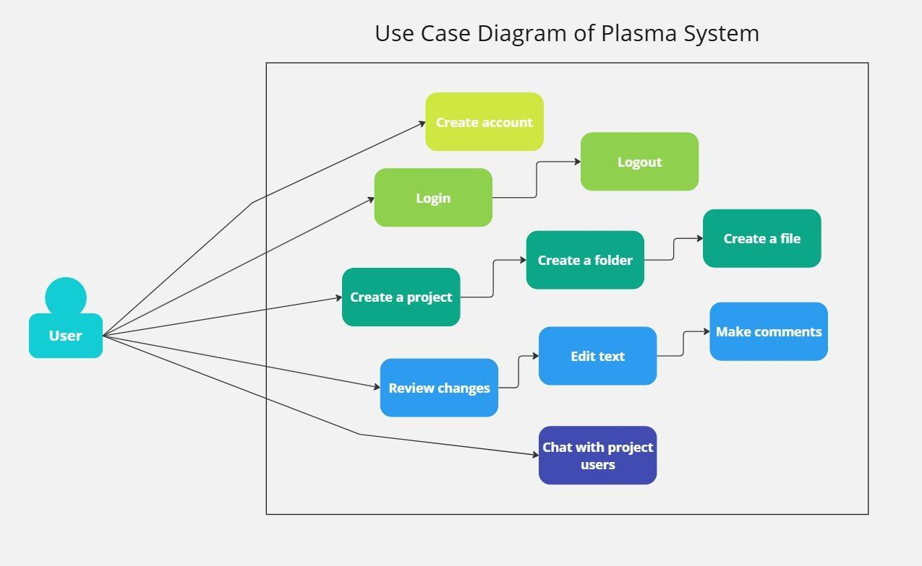

* **Software architecture**

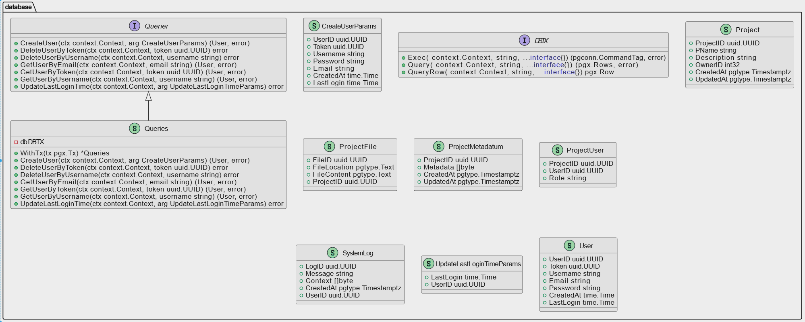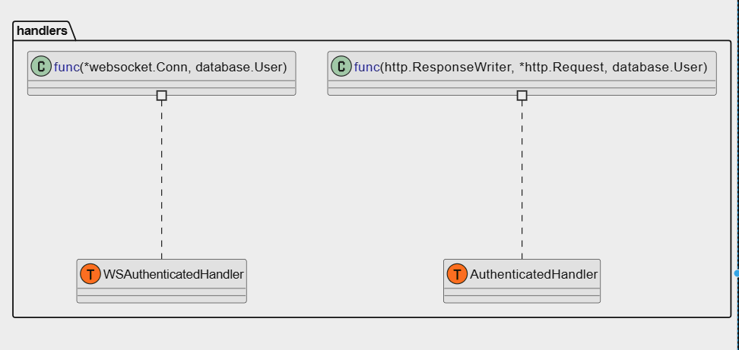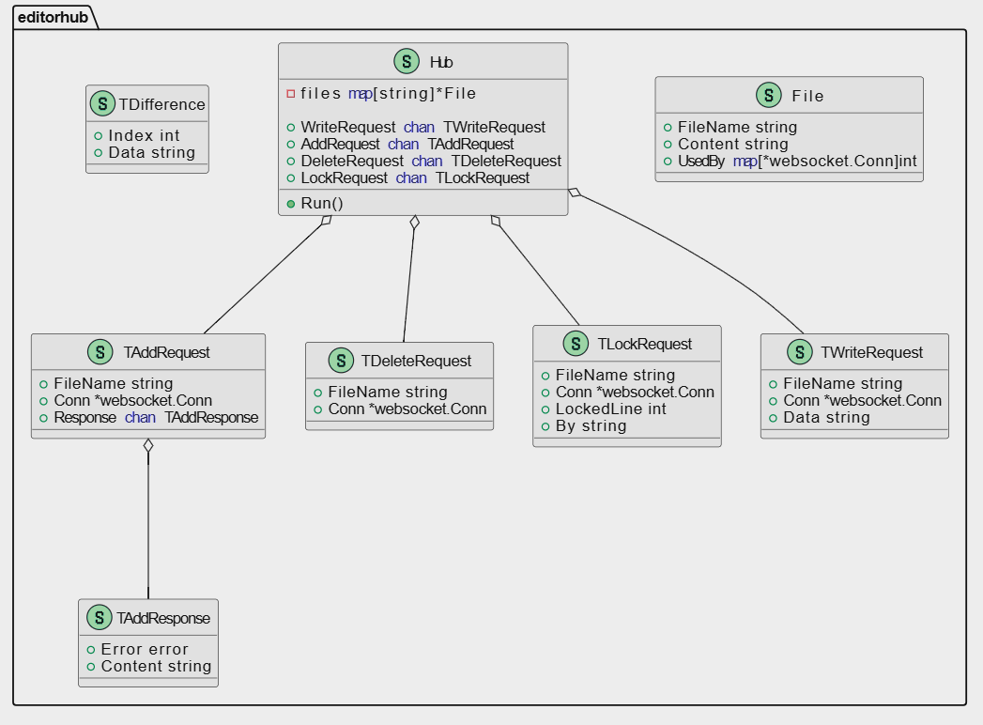

* **Decomposition of the system into modules**

*To see component diagram refer to .puml in /code/uml folder.*

* **Conceptual Data Base model**

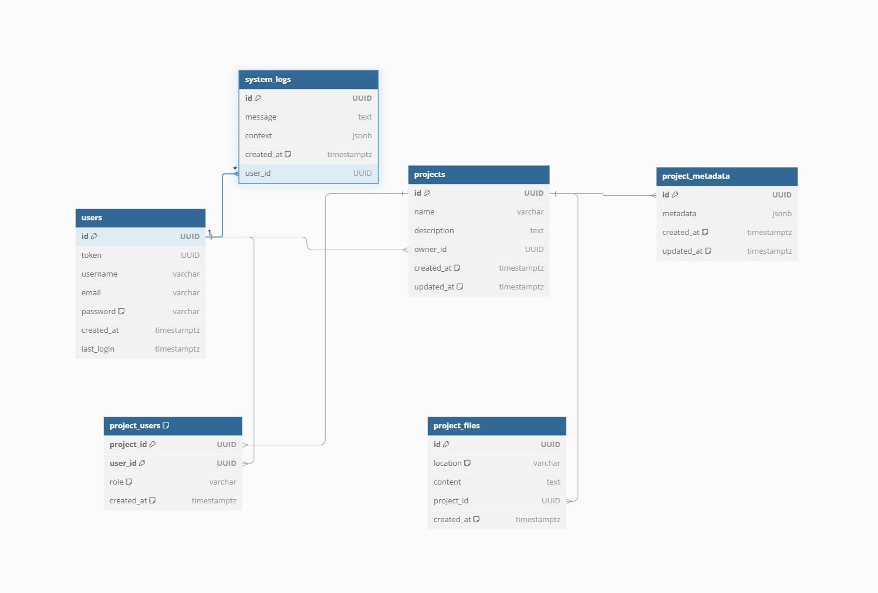

* **Resorces**
* **Acronyms**

*An explanation of any specific terms / acronyms used in this document.*

| **Acronym** | **Description** |
| --- | --- |
|  |  |
|  |  |
|  |  |

* **Others**

*Internet sites from which the information was taken.*